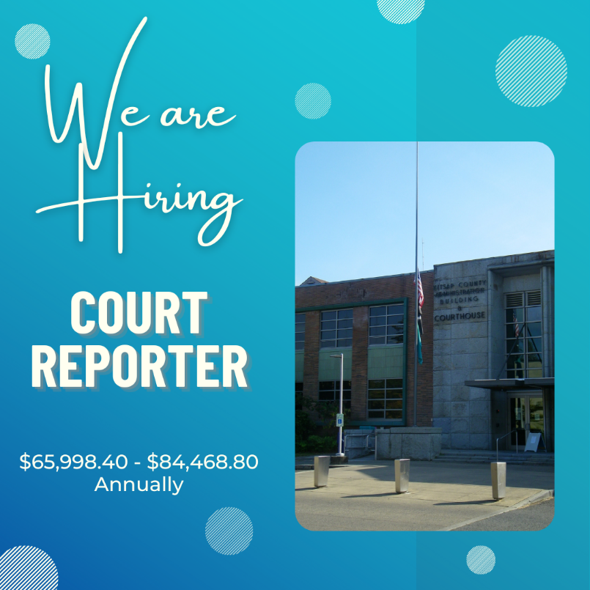
The Kitsap Superior Court is looking for exceptional Court Reporters to join our team! These positions are responsible for accurately recording all courtroom and chamber proceedings, hearings, ex parte, pro se dissolutions, domestic violence calendars, paternity calendars, criminal court, and any other process requested to be reported by the judge. If this matches your expertise, apply today!

QUALIFICATIONS FOR PERFORMANCE OF THE ESSENTIAL FUNCTIONS:
Required Education and Experience:
- Report and transcribe accurately 175 wpm of the judge's charge or 200 wpm of testimony each for five consecutive minutes.
- Proficiency in real-time court reporting and experience reporting in Washington Superior Courts or Courts of General Jurisdiction in other States.
- Three or more years of experience in court reporting
Criminal Conviction Standards:
- The successful incumbent will or may have unsupervised access to children under 18 years of age, a vulnerable adult, or a vulnerable person, or access to a secured/confidential facility or computer system(s). As a result, Kitsap County will be conducting an extensive criminal background check by law enforcement agencies, which may include fingerprinting.
Please review the following list of disqualifying crimes and negative actions to determine if you meet our standard for this position: https://www.dshs.wa.gov/sites/default/files/FSA/bccu/documents/Secretary%27sCrimesListforALLPrograms.pdf

Required Licenses, Certificates, Examinations/Tests and Other Requirements
- Please note: The incumbent is responsible for obtaining and maintaining all of the following required licenses, certifications and other requirements.

Prior to employment, the successful candidate must:
- Possess a State of Washington Court Reporter Certification through the Department of Licensing per Washington State Law or Registered Professional Reporter (RPR) certification through the National Court Reporter Association
- Pass a criminal history background check through law enforcement agencies.
- Pass all job-related examinations/tests necessary to demonstrate required knowledge, skills, and abilities, as determined by the hiring authority at the time of job posting.
- Be bondable.

PHYSICAL REQUIREMENTS AND WORKING ENVIRONMENT
(The physical demands described are representative of those that must be met by the employee to successfully perform the essential functions of this job. Kitsap County provides reasonable accommodation to enable individuals with disabilities to perform the essential functions.)
- Work is performed primarily in a courtroom setting.
- Requires clear speaking and adequate hearing sufficient to communicate effectively and respond appropriately.
- Positions in this class typically require: bending, stooping, reaching, handling/grasping documents, sitting for extended periods of time, walking short distances, vision sufficient to read source materials and computer screen data, and repetitive motions for computer use.
- Requires exertion of force of up to 30 pounds occasionally and/or 10 pounds frequently to lift/carry/move objects, files, and other materials.
- Sufficient hearing to accurately capture/transcribe court proceedings.
- Incumbents may be exposed to potentially hazardous conditions when dealing with disgruntled or hostile individuals.

This is a full-time position with a wage scale ranging from $65,998.40 - $84,468.80 annually and offers medical/dental/vision, life insurance, participation in the PERS State Retirement Plan, 11 paid holidays with 2 additional floating holidays per year, 8 hours of vacation, and 8 hours of sick leave , both accrued monthly.
To view additional optional benefits, an illustrative example of duties, and to apply, please visit our website: COURT REPORTER | Job Details tab | Career Pages (governmentjobs.com)

